**EC2 linux Hands on lab**

* Create a new Key Pair

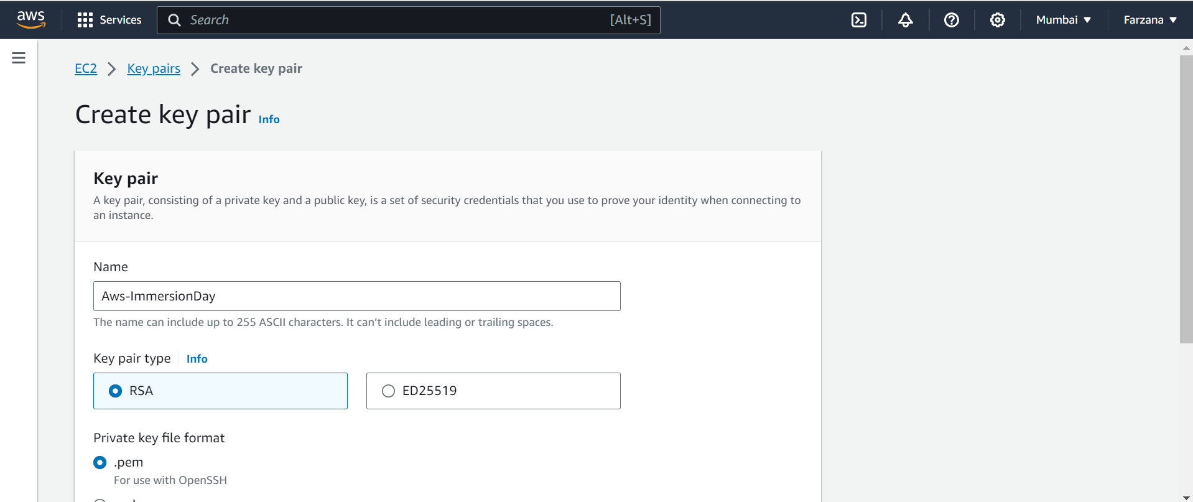

**Launch a web server Instance**

We will launch an Amazon Linux 2 instance, bootstrap Apache/PHP, and install a basic web page that will display information about our instance.

Click on **EC2 Dashboard** near the top of the leftmost menu. And Click on **Launch instances**.

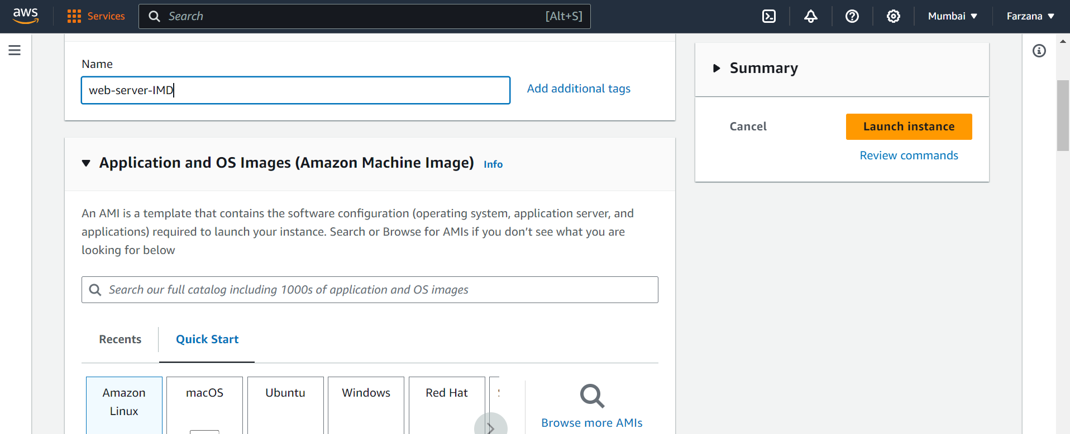

**Enter the user data to Launch the instance.**

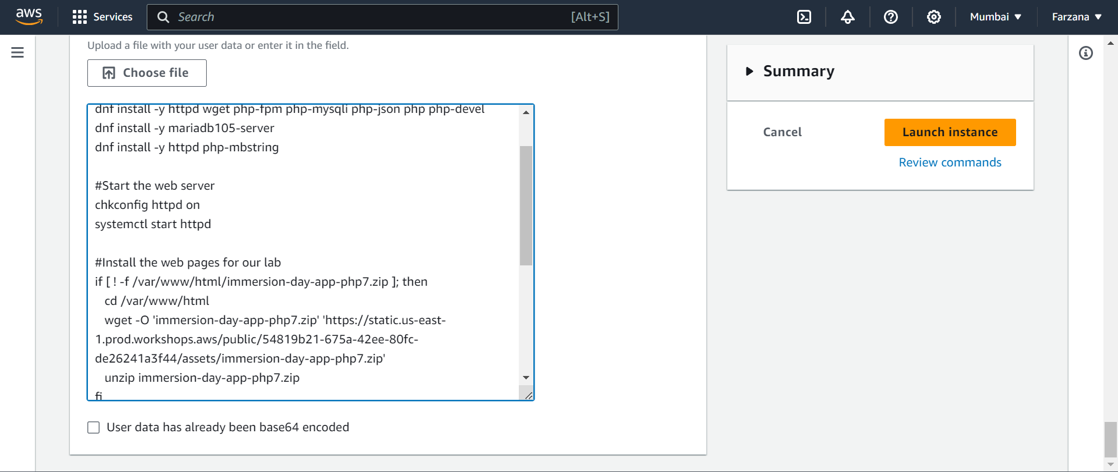

1. Click the **View Instances** button in the lower right hand portion of the screen to view the list of EC2 instances. Once your instance has launched, you will see your Web Server as well as the Availability Zone the instance is in, and the publicly routable **DNS name**. Click the checkbox next to your web server to view details about this EC2 instance.

The EC2 instance’s Public DNS name can be found in the console by reviewing the **Public IPv4 DNS** name line highlighted above. You should see a website that looks like the following.



Connect to your Linux instance using Session Manager

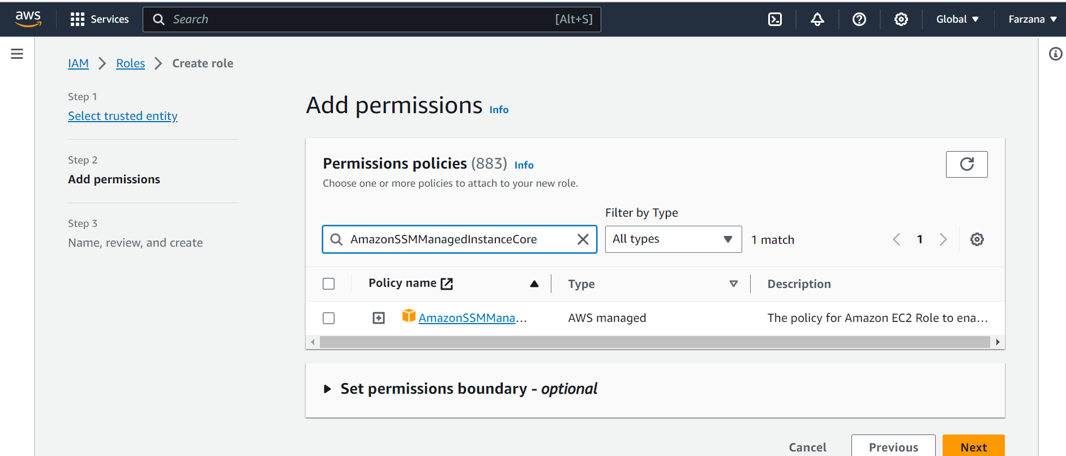

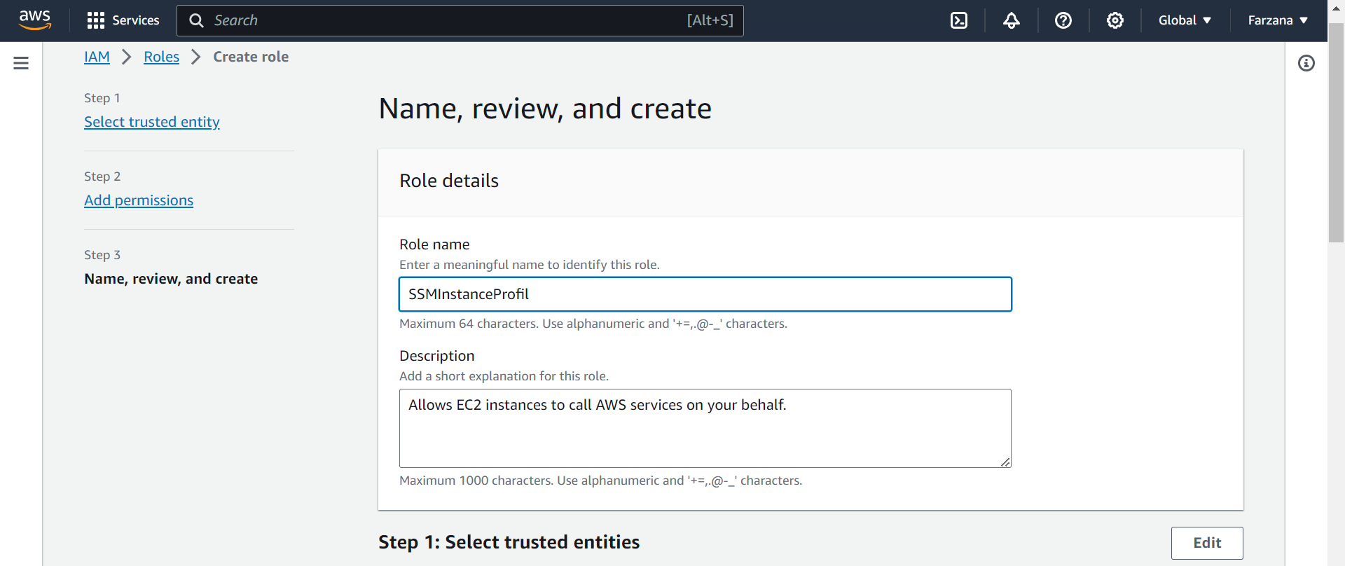

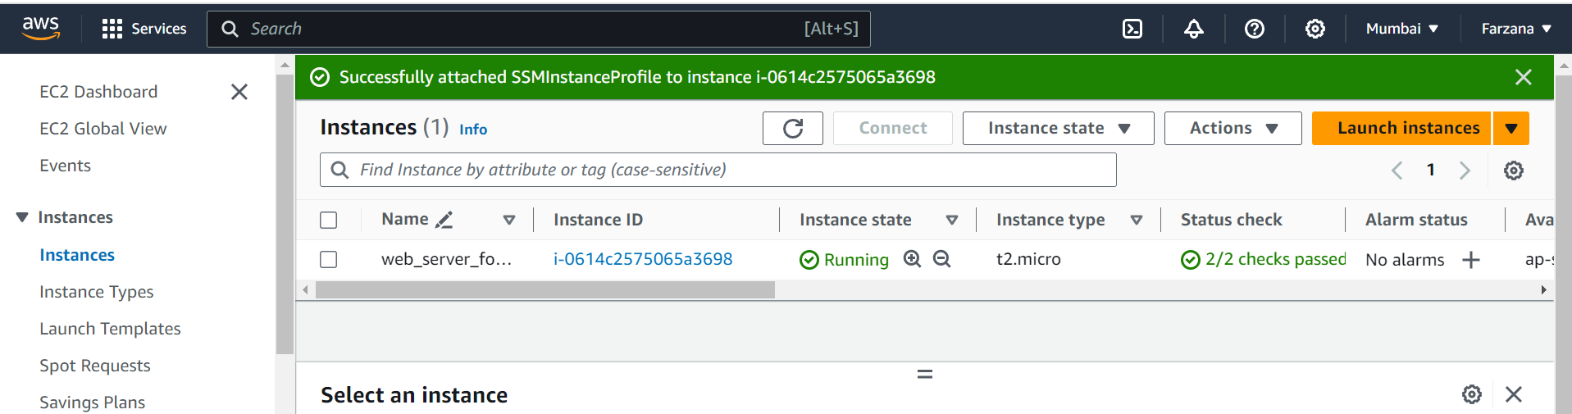

# 

# Connect to your Linux instance

